Assignment by SAI

Step one VPC creation—3tier VPC

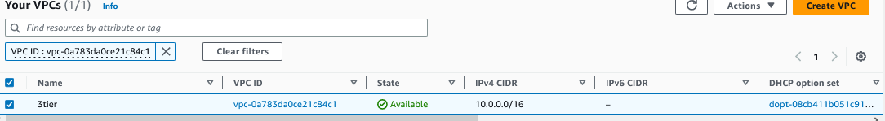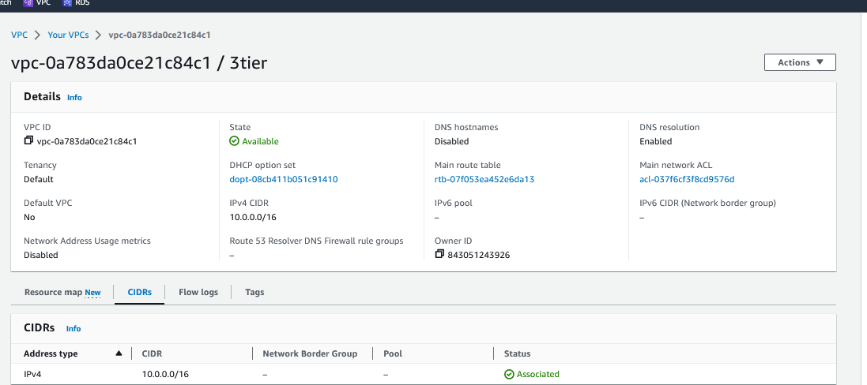

Step-02.

Creation of subnets

Webapp-01 and webapp-02 fro presentation layer

App-01 private and App-02 private fro application layer data-01 and data-2 for data layer

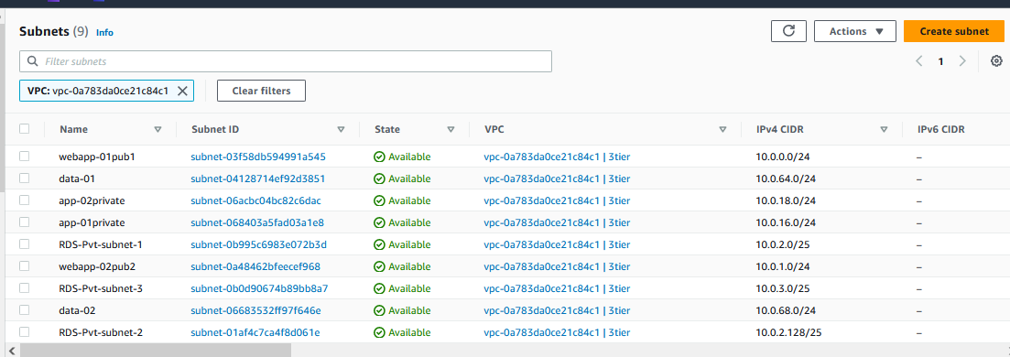

03.Create Internet gateway VPC attached

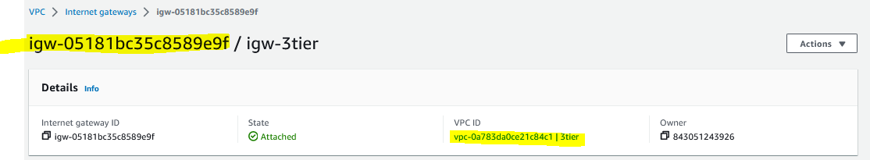

04 Create Route table

1. public3tier

2. private 3tier

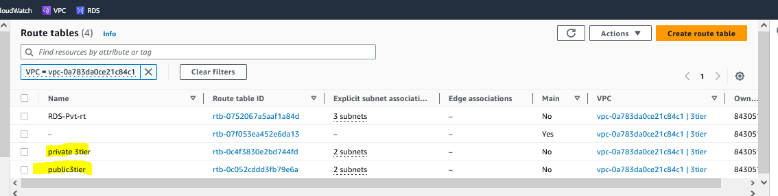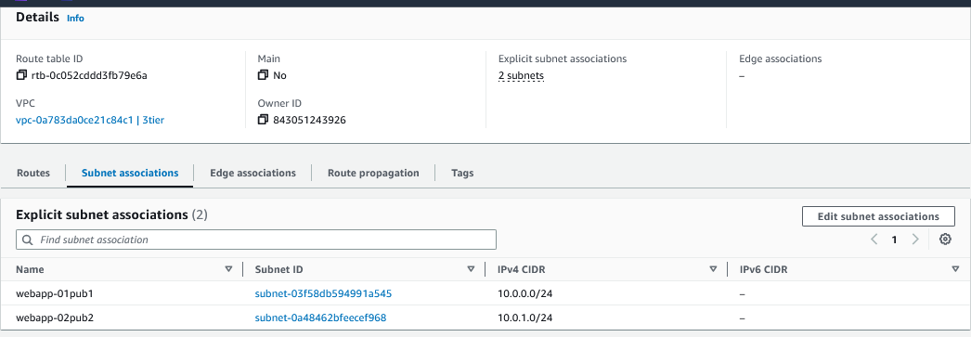

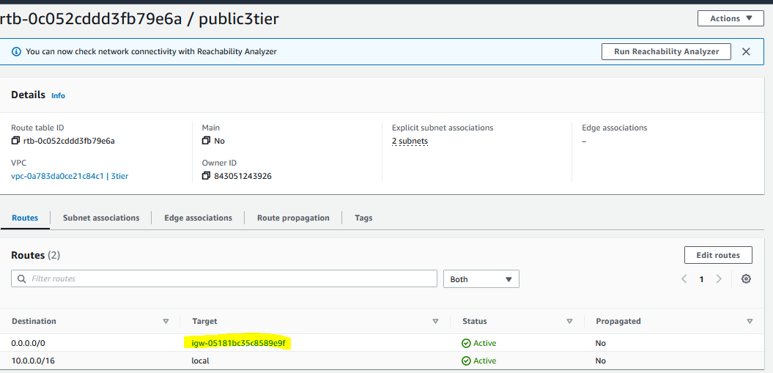

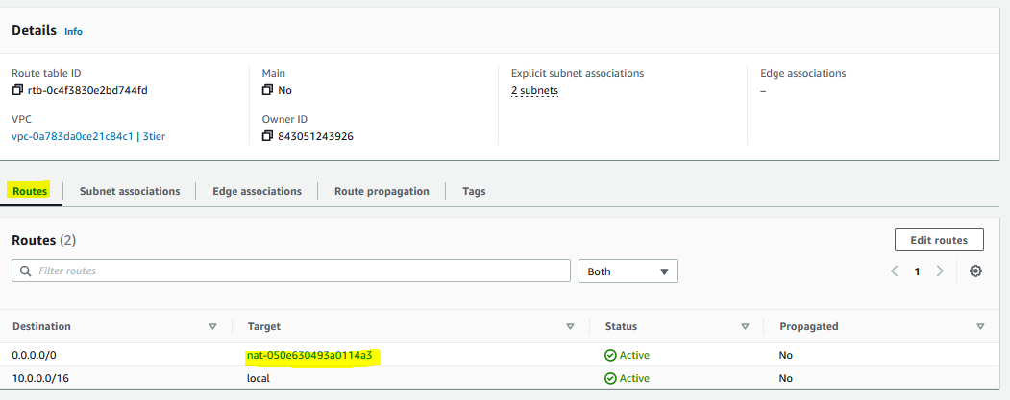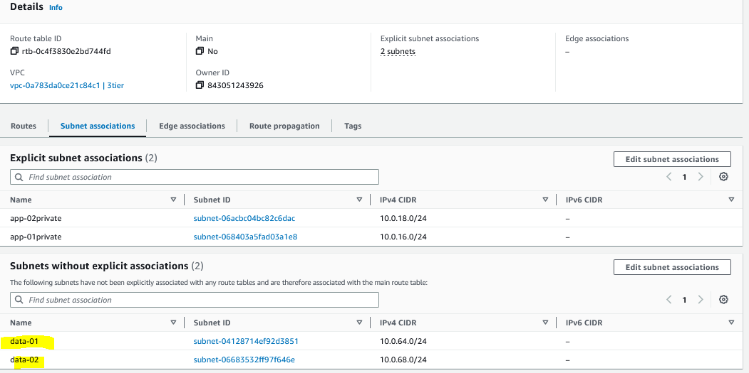

5.NAT gateway

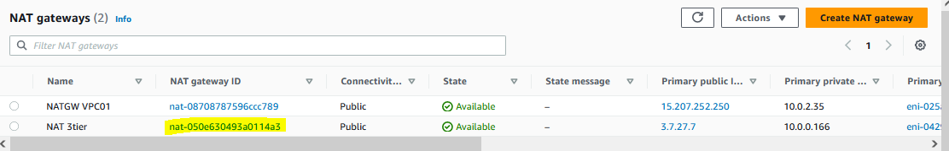

**IN EC2-**

**Launch template for webapp layer and application layer**

**Name the Machine –**

**Instance type –t2 micro**

**Create new security group**

**Network setting--**

**Add correct VPC**

**Inbound settings --SSH –port -22 – custom .00.00.00.00**

**Add the script**

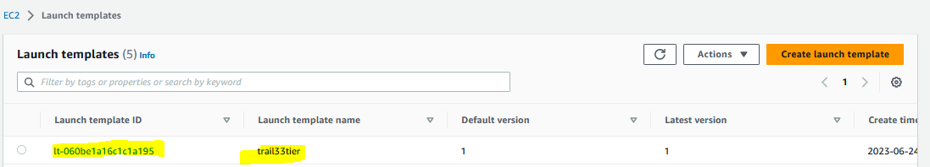

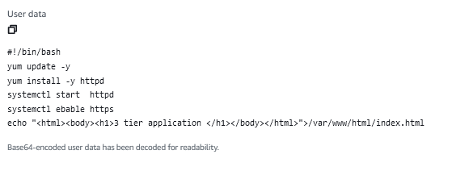

Step -7 Auto scaling 